Banks, John Charles G, Dr (by Peter Kanowski in the Forester 2004 and Australian Institute of Alpine Studies Newsletter 2004)

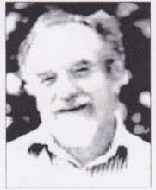
Born 28.5.1942 died 22.3.2004.
Dr John Banks contributed greatly to Australian forestry through a 35-year career at The Australian National University - almost the entire duration of his professional career. John came to ANU from north Queensland, where he was an inaugural student and student union president at the new Townsville University College. He graduated in Forestry from the ANU in 1966, as one of the first graduands after the forestry degree was transferred from the former Australian Forestry School. He was appointed to the ANU’s Department of Forestry initially as a Senior Technical Officer, and then Senior Tutor in 1969; John was promoted to Lecturer in 1978 and Senior Lecturer in 1992. He completed his ANU MSc, on taxonomy of Eucalyptus viminalis, in 1972, and his ANU PhD, on the use of dendrochronology to interpret dynamics of snow gum forests, in 1982. He collaborated with Lindsay Pryor. John assumed Pryor’s mantle as the authority on Canberra’s urban trees, and was Tree Advisor to the ACT Government at the time of his death.

Peter Kanowski

